Polk Trails Adopt-a-trail/ Trail Stewards Program
Is there a trail in Polk that you feel a strong connection to? A trail near your home that you frequent? “Adopting” a trail and becoming a Trail Steward is a great way to give back to the trails system in Polk County!

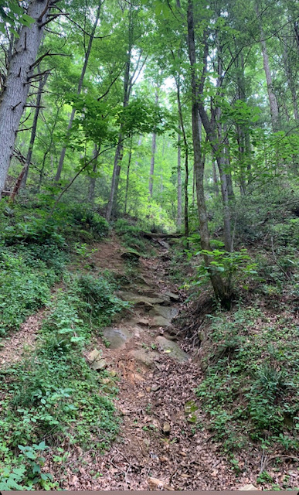
The purpose of this program is to become more thorough and methodical in maintenance of our wonderful 29+ miles (and growing) of trails here in Polk. Trail Stewards will essentially serve as the ‘eyes and ears in the field’ for the Recreation Coordinator and local land trusts. No trail experience is necessary to be a Steward!

1. Decide which trail or portion of trail you’d be interested in being a steward for.
2. Contact the Recreation Coordinator (recreation@polknc.org) and let them know what trail you’d be interested in.
3. Schedule a meeting with the Recreation Coordinator and possibly representatives of maintaining organization (i.e. PAC, SCLT, etc), preferably at the trail you will be stewarding, for a bit of trails training and things to look out for.
4. On at least a monthly basis, hike the trail and take notes on conditions and possible problem areas.
5. Report those conditions to the Recreation Coordinator and pertinent maintaining organization (if any).

Responsibilities:
• Hike your trail on at least a monthly basis. Take note of issues such as blown down trees on the trail, dangerous dead trees or limbs hanging over the trail, muddy/washed out sections, overgrown vegetation crowding the trail, vandalism, litter, unauthorized fire pits, etc.
• Report any issues, preferably with specific location and photos, to the Recreation Coordinator and organization associated with the trail
• Trail maintenance (clearing branches or overgrown shrubbery) and degree of maintenance by Trail Stewards is up to the individual steward
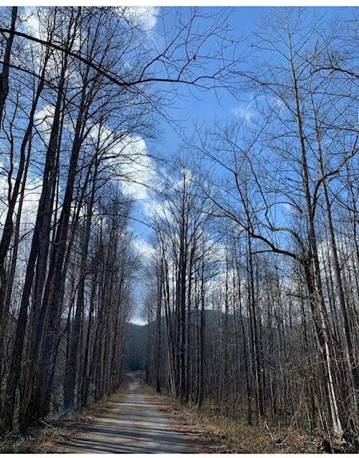
• Stewards can do maintenance themselves or simply report to the Recreation Coordinator and organization associated with the trail who will do it or plan a work day. Stewards are asked to report any time they do maintenance
• Stewards are asked not do any trail ‘construction’(i.e. building stairs, water bars, re-routing the trail, etc.) projects without the consent of the Recreation Coordinator and/or organization who manages the trail (i.e. PAC, SCLT, etc)
• Stewards are asked not to use chainsaws on their own and to talk with the Recreation Coordinator prior to using a chainsaw or any motorized equipment on the trail
• Stewards may be contacted regarding the conditions of their trail for planning purposes by the Recreation Coordinator
• Trail Stewards are encouraged to send photos of their experience to the Recreation Coordinator to be used (with permission & credit) on the Polk Trails Facebook and/or website

Trails that are “up for adoption”:
Little Bradley Falls: 1 mile
Saluda Nature Park: 1.1 mile
Bradley Nature Preserve (Saluda):1.5 miles
Tom Raymond Fitness Trail: .5 mile
Big Bradley Falls: 1 mile
Tryon Missing 40: 1 mile
Isothermal Community College Loop: .5 mile
Vaughn Creek Greenway: .8 mile
Melrose Falls: .5 mile
Woodland Park: 1 mile
Norman Wilder Forest (Multiple Trails/ sections): 3 miles total
Alexander’s Ford: 1.3 miles

